**Ms.Saumya is working on a MySQL table named ‘Hotel’ having following structure:She need to perform following task on the table:**

**i. To fetch last 2 characters from the user_id column.**

**ii. To display the values of name column in lower case.**

**iii. To display 3 characters from 3rd place from the column city.**

**Suggest suitable SQL function for the same. Also write the query to achieve the desired task.**

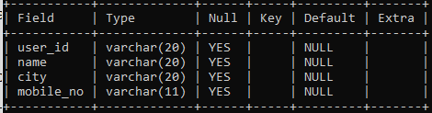

* -- (i)
* select substr("user_id",6,2);
* -- OR
* -- select substr("user_id",6);
* -- (ii)
* select lower("NAME");
* -- (iii)
* select substr("city",3,3);